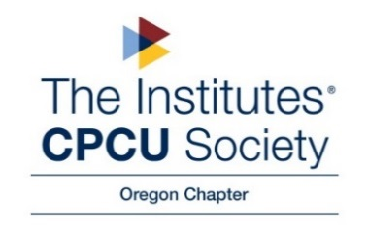

Minutes of the CPCU Oregon Chapter Board Meeting
10/27/2022

Opening: Meeting called to order at 8:30 am by Lindy Gibbons

Present: Lindy Gibbons; Ena Pullman; JP Agnesse; Amber Lohmeier; Pat Morrill; Gabrielle Blanco; Linda Rooke.

Absent: Jon Gice

I-Day
- Gabrielle has not been able to reach anyone at Potluck in the Park. She will try and call on Sunday. They do have a short video on their website we can use at I-Day and a link attendees can use to donate.
  - Donation matching: in lieu of a dollar-for-dollar match, the Chapter will donate $500
- Promo code (CPCU 2022) can still be used on Eventbrite for registration
  - Any additions to the registration list can be sent via email to Linda and JP
- JP and Linda are working on name tags; lanyards have arrived
- Final I-Day planning meeting scheduled for Wednesday, Nov. 2nd @ 8am via Teams (invite sent 10/27)

New Business

- Officers/Board 2023:
  - Linda Rooke -President
  - Lindy Gibbons- Immediate Past President
  - Open: President-Elect
  - Pat Morrill- Director of Membership
  - Ena Pullman- Secretary
  - Amber Lohmeier- Treasurer
  - Gabrielle Blanco- Social Media
  - JP Agnese- Director of Education

- Possibilities President-Elect/Board:
  - Sarah Finseth- President-Elect?
  - Jo Speight- Board Member at Large?
  - JP will reach to co-worker

- Should we consider changing the by-laws for a possible 2-year term?

- Christmas/Networking Event Dec 6th 4-6 pm.

  - Possible location: Stock Pot Broiler: 8200 SW Scholls Ferry Rd Beaverton, OR 97008 503-643-5451 *They have a separate room

  - Lindy will check on pricing and get back to the group

Next Meeting
- Good Works Project?

Adjournment: Lindy called the meeting to close at 9:20 a.m.

