CPCU I-Day Committee Meeting
03-09-23 Agenda

- Date and time – We have selected 11/2/2023
- 3 CEs
- Rough Itinerary:
  - 1pm-2pm CE
  - 2pm-3pm Conferment/Officer remarks & Good Works
  - 3pm-4pm CE
  - 4pm-5pm CE
  - Social Hour/Networking
- How many designees do we have – Pat
- 4 (2023)
- CPCU Conferment Officer
- Jennifer Drum?
- Venue – Happy/Social Hour options
- Crown Plaza- JP
- Holiday Inn- Pat
- Theme or Title of Program
- Next meeting 2-3 ideas & potential speakers
  - State of the Market changes (panel): P&C, reinsurance, forecasting
    - Uncertainty
    - Public vs. private
  - Potential legislative changes?
- Save the Date for sponsors and on website (2022 sponsors)
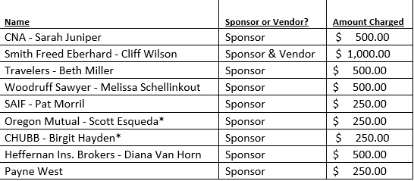
- Budget
- 2023 - $5000
- 2022 - $4400

- Do we want to have a committee/speaker dinner the night before?
- Speaker Lunch (same day)?
- Printing – Program/Name tags – cost of printing last year?
- 2022 – under $200
- Speaker Gifts?
- 2022 - $50 Amazon Gift Cards (ea. speaker)
- Committee assignments?
Next Meeting: 4/13 @ 8:30AM (part of BOD meeting)- via Teams

Upcoming Events:
4/17/23: Cyber Symposium- Presented by Travelers (Lindy will provide info- Ena will distribute)
5/4/23: May Speaker: DEI- SAIF Speaker (Ena will look into)

