
Opening: Teams Meeting called to Order at 8:30 (2/2/23)
Present: Linda Rooke, Pat Morrill, Lindy Gibbons, JP Agnesse, Amber Lohmeier, Gabrielle Blanco

Budget: (sent 1/12/23)
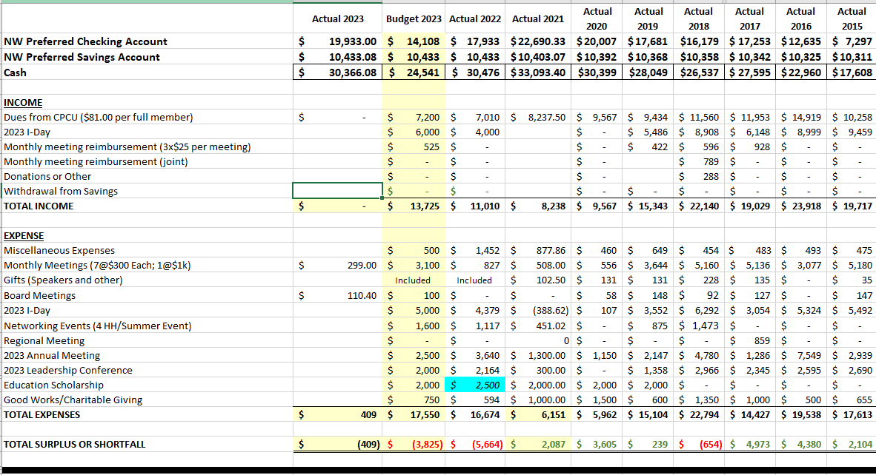
- Over budget 2022
  - Did not move any funds from savings
- Over budget 2023
  - Currently 98 members
  - Minimal success/interest with the education scholarship
    - Shift funds to cover 1st year dues for recent designees?
  - Eliminate quarterly HH/networking event
  - Monthly meetings
    - Charge for non-members
    - Pathways member- reduced cost?
- Ideas to increase revenue
  - Increase chapter dues

Next meeting 2/22 @ 8:30

No Attachments

