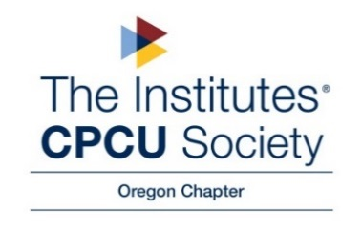

Minutes of the CPCU Oregon Chapter Board Meeting

Opening: Meeting called to order at 8:30 am by Lindy Gibbons

Present: Gabrielle Blanco; Linda Rooke, Ena Pullman, Pat Morrill, Lindy Gibbons; Jennifer Drum; Karen Alger; Amy Patton; Jo Speight; Chris Stanley; and JP Agnesse

Absent: Amber Lohmeier
Old Business:
- Educational Outreach
  - Cascade High School- Career Fair 2/9 (Pat/Ena)
    - Opportunity to speak with juniors/seniors about various opportunities within the insurance industry
- Pat moved to nominate Chris Stanley (SAIF) as President-Elect for 2023, Linda Rooke seconded, and the motion was approved. (Motion and vote conducted via email 2/3/23)

New Business:
- Introduction: Jennifer Drum, New Oregon Governor
- Status of budget
  - Eliminate scholarship- minimal interest
  - Eliminate bi-monthly Happy Hour event- focus on one summer event
  - Increase membership dues? (Amy Patton)
  - (Jennifer Drum) PNW is having the same challenges- minimal interest for in-person events. Venues are expensive- they’ve had success with virtual event
  - Linda moved to accept the budget, seconded by Pat Morrill, and the motion was approved by all members.

Regional leadership meetings/trainings will be offered at a reduced cost (Amy)
- Focus on chapter leadership development
- Virtual (May?)

Leadership (March 28th-29th)- Tampa, Florida:
  - Gabrielle Blanco

In2Risk (Oct 5th-7th) Washington DC:
  - Chris Stanley
  - Linda Rooke
  - Costs
  - Airfare/hotel/conference fee
  - Flat allowance ($2,500)

Monthly Chapter meetings- Upcoming
  - Mar (3/24)- Ethical Time Management presented by SAIF - virtual
  - Apr (4/6)- Fire Cause & Analysis- partner with OCA
    - Split cost with OCA?
    - Linda will obtain info on Fire, Cause & Analysis and send to Ena
  - Presenter has already filed for CE
  - Ena will set up Eventbrite Link
    - May (5/4) –DEI: Ena will check with Jessica Jack (in-person event) – if not avail, JP will check with PGE (ESG- Environmental, Social, Government)
      - Circle of Excellence: Diversity and Inclusion Activity Conduct a dedicated activity in support of diversity and inclusion during a chapter meeting.
    - June Happy Hour Event & CE (Lindy)

IDay
- November 2nd
- Venue- Holiday Inn in Wilsonville?
- Theme/topics?
- IDay planning meeting/committee
  - 3/9 BOD Meeting focus on IDay planning- Linda will create an agenda

Adjournment: Lindy called the meeting to close at 9:26 am

Next Board Meeting March 9, 2023 @ 8:30 via Teams.

Attachment: 2023 Budget

