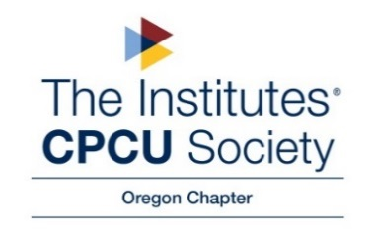

Minutes of the CPCU Oregon Chapter Board Meeting
12/14/21

Opening: Jon called the Zoom meeting to order at 10:33 am.

Present: Lindy Gibbons, Amber Lohmeier, Vilay Siharath, Pat Morrill, Jon Gice, Linda Rooke, Ena Pullman

Absent: Averina Salveson, Darcy Andrews, and Aaron Selburg,

Old Business

- November Minutes were approved via email vote, posted to OR CPCU Chapter Documents
New Business
- Good Works & Social Event Recap Amber: (Amber, Jon, Pat) performed some Good Works 12/5/21 at a church in Milwaukie- packing (72) hot meals/care packages for community members in need. It was a meaningful and impactful event. “Win/Win Experience”. Discussed charity donations – confirmed payment has been sent to Best Alliance in the amount of $500. Jon moved that a $500 check be sent to the Oregon Food Bank – seconded and motion approved by all attendees.
- Social event- Jon suggested New Years’ event 2nd or 3rd week in January 2022 (Brunch/Happy Hour). Lindy discussed who we would attract based on the time. Jon will look into possible event at Oswego Hills Winery or Ember and Vine (Hillsboro). Per Lindy: Oswego Hills Winery (website) prices are $20 per person- drinks are additional w/ a $1,000 deposit. Pat discussed location – Oswego would be centralized for most people.
- Amber Lohmeier provided the Treasurer Report provided by email on 12/14/21.
- Questions, Comments, Concerns
  - Jon’s thanked Aaron, Darcy, Averina, Linda for their work; Pat for access to SAIF webinars
  - National Chapter – Certificate of Appreciation will be sent via email (Amber, Vilay, and Pat)
  - Pat: Enjoyed everyone’s perspective offered throughout the year. Will look into how many CPCU’s attended the 12/14 CE (Evaluating Your Safety & Health Program: Building a Foundational Culture webinar).

Next Meeting: 1/8/22 (Jon’s house)- Planning Meeting for 2022

Adjournment: Jon called the meeting to close at 11:20 a.m.

No Attachments

