I DAY Planning Meeting Minutes 6/29/22

Advertising strategy – JP created SAVE THE DATE
- Save the Date sent 6/16 & send again July; Registration in Aug/Sept/Oct

Locate paperwork for vendor/sponsor. Any personal relationships? Assign and contact
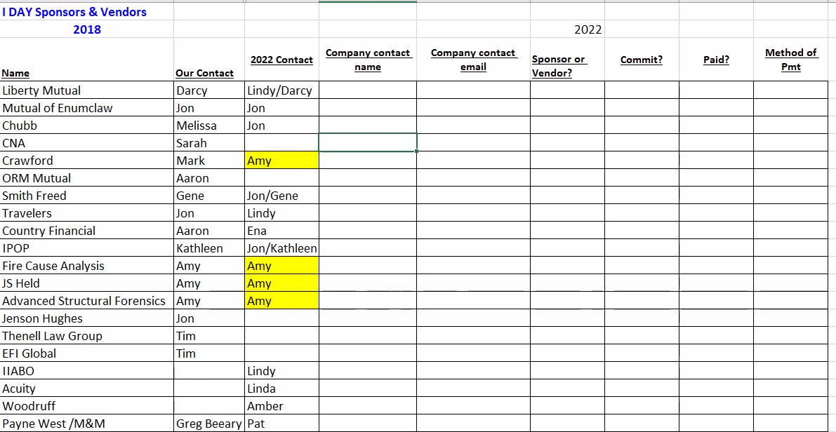

*update with company contact name (first/last)
- Any companies not listed above, run by the group first to confirm we are not duplicating efforts

- Template email – Jon will locate/create and send out

Vendor (purchase table space) vs. Sponsor- (donation) *see attached
- Leave it up to the vendor/sponsor as to if they want to have space to set up a table (breakfast/breaks)
  - $250 breakfast sponsor (1 free ticket)
  - $500 lunch sponsor (2 free ticket)
  - $1000 platinum sponsor (package includes 3 tickets, vendor table, “Commercial” time to advertise service)

Next Meeting 7/20 @ 9am:
Outline from speakers (due end of July)/Status of CE’s (45-day wait time)
Confirm location/contract
In2Risk -who will be attending?
Intern (Linda)
Scholarship – panel requires 7 members
- Two applications were received:
  - Jon has paper application
  - Karina Wurtz

  Your Name: |  |  |  | Company:
Email:
Phone:
Sponsorship Options (Select One):
 |  | Full I-Day Sponsor - $1,000 for the ultimate company recognition. Company highlighted in program, Vendor table, post your signage and 3 free tickets to the event.
 |  | Lunch Sponsor – $500 for recognition in the program for assisting with lunch costs and 2 free tickets to the event.
 |  | Breakfast Sponsor - $250 for recognition in the program and 1 free ticket to the event.
 |  | Vendor – $250 for an all-day table display and one free ticket to the event.
Payment Options (Select One):
 | PayPal – Email this completed form to alohmeier@woodruffsawyer.com and an invoice will be sent to your email address indicated above with a link to PayPal.
Mail – Send this completed form and check to: Oregon CPCU Society Chapter
PO Box 202, Tualatin, OR 97062




For more information, please contact Amber Lohmeier:
alohmeier@woodruffsawyer.com

