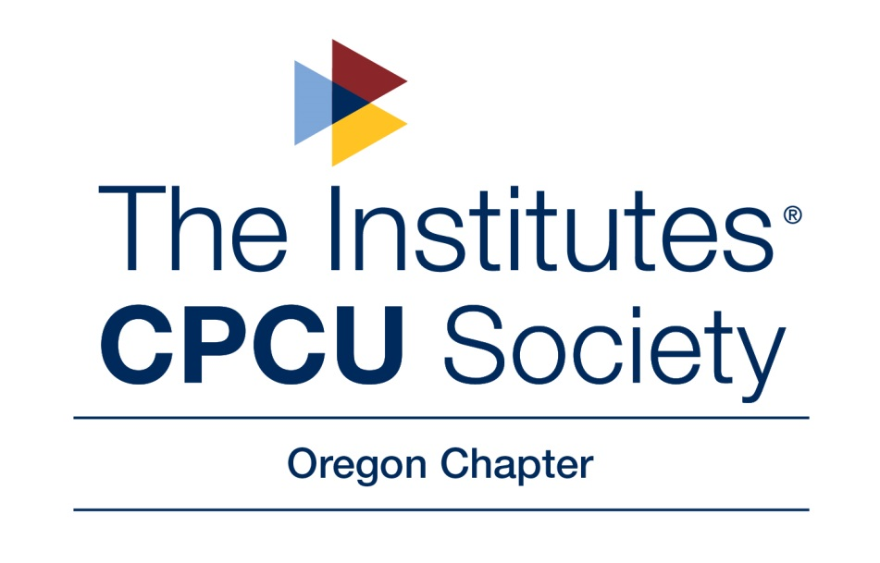
January 2019 Board Meeting Minutes
Date: January 16th, 2019 Time: 12:00 pm – 1:00 pm
Location: Gustav’s Pub & Grill, 10350 SW Greenburg Rd, Tigard, OR, 97223
Invitees: Gene Menke, Greg Beery, Aaron Selburg, Jon Gice, Amber Lohmeier, Melissa Castellano, Amy Patton, Kathlene Henry, Darcy Andrews, Averina Salveson & Lindsay Emick

Meeting Called to Order at 12:00 pm by Gene Menke
All Invitees noted above were present, with the exception of Aaron Selburg & Kathlene Henry.
Budget
Jon presented the budget as the outgoing Treasurer. Our goal is to not have “surplus” money at the end of the year, as we are a non-profit.
- Areas of Discussion:
- Holiday Party Expense – given the number of attendees that we had in 2018, it was suggested that perhaps we consider forgoing the Holiday Luncheon this year as we have been having it at a nicer hotel downtown the last few years and that is somewhat expensive. Darcy suggested that we consider having a volunteer event to give back to the community instead, which would be good for morale among membership and also cheaper or free for the Chapter. She had participated in an event called “Shop with a Kid” in December 2018, which was a worthwhile and enjoyable cause that we should consider. Kathlene is usually in charge of the Holiday Luncheon and since she was not present to discuss, Gene Menke said he would get with Kathlene separately to discuss options for this year.
- Leadership Summit – it was decided that only 1 person would go this year, instead of 2 like last year. The intention of which is to reserve the money for the new 2019 College Scholarship Award.

2018 Chapter of Excellence
Gene will be following the checklist/guidelines again for the Chapter to be included as part of the Chapter of Excellence. We have received COE status the last few years, so it was suggested that we want to continue this. There was no opposition noted and all present were pleased with the Chapter’s continued COE status and recognition.
2019 Operating Plan
There will be 5 Board Meetings, organized by Gene, as President. Board Meetings usually follow a regularly scheduled Chapter Meeting, except for the January Board Meeting which is for planning. We will have 10 Monthly Meetings. This format has not changed from 2018.
- Meetings/Assignments for 2019
  - Annual Board Planning Meeting (January 16th, Owner: Gene)
  - January Chapter Meeting (January 30th @ OMI in McMinnville, Owner: Melissa)
  - February Chapter Meeting (February 12th, Joint Meeting w/OCAA, Owner: Greg)
  - March Chapter Meeting/Board Meeting (Already set for March 13th, Owner: Gene)
  - April Chapter Meeting (Owner: Aaron, Salem-Focused Member Meeting @ Country Companies)
  - May Chapter Meeting (Owner: Darcy)
  - June Chapter Meeting (Owner: Amber)
  - September Chapter Meeting (Owner: Amy)
  - October Chapter Business Meeting (Owner: Gene)
  - November Chapter Meeting (I-Day, Owner: Jon)
  - December Chapter Meeting (Gene is going to form a committee with Kathlene & Darcy to discuss options for the normal Holiday Luncheon)
Every Board Member was assigned a monthly meeting per the discussion, as noted above.
- Social Events/Networking Ideas
  - It was suggested that we continue a joint networking event with IPOP, like we did last April. Kathlene was suggested as the coordinator due to her longtime involvement in IPOP.
  - Greg volunteered to head a committee to plan a Summer Networking Event. Lindsay and Averina agreed to join the committee.
- Service/Community Project
  - Darcy volunteered to head up this effort. She is also part of Gene’s Holiday Luncheon/Volunteer Event Committee with the intention of creating a volunteer event for members in December.
Leadership Summit (April 4 - 6 in Denver, CO)
There was discussion around who would be attending the Leadership Summit. Melissa is the only titled Board Member who has not yet attended, so she was nominated to attend on behalf of the Chapter. Melissa suggested that it was fair to also send a second person to spread the opportunity among all members as we have in some prior years. Ultimately, it was decided that only one person would attend to reserve additional money in the budget for the Scholarship Award. All were in agreement.
Annual Meeting (September 21 – 24, New Orleans, LA)
It was suggested that as the President-Elect, Aaron would attend the Annual Meeting. All were in agreement.

Social Media Channels Assignments
- Twitter (Amy)
- LinkedIn (Several people have access – Greg, Melissa, etc.)
- Facebook (Several people have access – Greg, Melissa, etc.)
- Instagram (Amy)
Scholarship Program Committee Presentation
The Scholarship Committee consists of Averina, Lindsay & Darcy, with Greg as Chairman. Jon had provided a template from his prior experience in the Connecticut CPCU Chapter as a framework for a scholarship program for the Oregon Chapter. Greg presented the idea that we should offer a scholarship this year. There was some discussion regarding how many scholarships (1 versus 2). It was decided that since this is our first year doing it, we would offer one $2,000 scholarship to an immediate family member of an OR CPCU chapter member in good standing who are pursuing a college degree. It was clarified if the scholarship is open to Members themselves, not just family members and it was decided that Members themselves are eligible. The copy presented had several typos, it was found that the copy we have isn’t the final copy. Greg would find the real final copy and post it online, as well as send an email to chapter membership announcing it is there.
Melissa agreed to check the PO Box for Scholarship Applications. She is not part of the committee and the process is intended to be “blind” so the committee is not allowed to know the names of the applications, so Melissa will remove identifiable information from the entries to share with the committee. This will ensure the most fair selection process, possible.
The motion was passed, there was no opposition.
Conclusion
Meeting ended at 1:04 pm and a reminder that our next Board Meeting will follow the March Chapter Meeting, was made.

